A
Mini project Report On
INTRUSION DETECTION AND PREVENTION SYSTEM

Submitted in partial fulfillment of the requirements for the award of
BACHELOR OF TECHNOLOGY
In
COMPUTER SCIENCE AND ENGINEERING
By
MOHD MUZAMMIL(24TQ1A05F5)
MOHD FEROZ(24TQ1A05F4)
MOHD ASHFAQ(24TQ1A05F3)
Under the Esteemed Guidance of
Mr.K.SRIKANTH

Assistant Professor

DEPARTMENT OF COMPUTER SCIENCE AND ENGINEERING

SIDDHARTHA INSTITUTE OF TECHNOLOGY AND SCIENCES
(UGC - AUTONOMOUS)

(Approved by AICTE , New Delhi & Affiliated to JNTUH , Hyderabad) Accredited by NBA and NAAC with ‘A+’ Grade
Narapally, Korremula Road, Ghatkesar, Medchal Malkajgiri(Dist)- 500088 2024 – 2025

 SIDDHARTHA INSTITUTE OF TECHNOLOGY AND SCIENCES 
(Approved by AICTE ,Affiliated to JNTUH , Hyderabad v Accredited by NBA and NAAC with ‘A+’ Grade
Narapally, Korremula Road, Ghatkesar, Medchal Malkajgiri(Dist)- 500088

CERTIFICATE

This is to certify that this Project Report entitled
Being Submitted

INTRUSION DETECTION AND PREVENTION SYSTEM

By
MOHD MUZAMMIL(24TQ1A05F5)
MOHD FEROZ(24TQ1A05F4)
MOHD ASHFAQ(24TQ1A05F3)
In partial fulfillment for the award of the degree of Bachelor of Technology in Computer Science and Engineering, Jawaharlal Nehru Technological University Hyderabad, is a record of bonafide work carried out under my guidance and supervision. The results embodied in this project report have not been submitted to any other University or Institute for the award of any Degree or Diploma.
Guide Head of the Department
K.SRIKANTK DR.V. SUMALATHA
Assistant Professor, Department of CSE HOD, Department of CSE

Internal Examiner External Examiner

DECLARATION

We, Pavani, Ujwala, Kamal Tej and Vamshi here by declare that the results embodied in this project dissertation entitled INTRUSION DETECTION AND PREVENTION SYSTEM is carried out by us during the year 2025 – 2026 in partial fulfillment of the award of Bachelor of Technology in Computer Science and Engineering from Siddhartha Institute of Technology & Sciences. It is an authentic record carried out by us the guidance of K.SRIKANTK, Assistant Professor, Department of Computer Science and Engineering

By
MOHD MUZAMMIL(24TQ1A05F5)
MOHD FEROZ(24TQ1A05F4)
MOHD ASHFAQ(24TQ1A05F3)

ACKNOWLEDGEMENT

Any endeavor in the field of development is a person’s intensive activity. A successful project is a fruitful culmination of efforts by many people, some directly involved and some others who have quietly encouraged and supported.
Salutation to be beloved and highly esteemed institute SIDDHARTHA INSTITUTE OF TECHNOLOGY AND SCIENCES for grooming us into Computer Science and Engineering( graduate, We wish to thank PRINCIPAL Dr.M.JANARDHAN for providing a great learning environment.
We wish to express profound gratitude to Dr.V.SUMALATHA, Assistant Professor and HEAD OF DEPARTMENT, COMPTER SCIENCE ENGINEERING, for his continuous encouragement to ensure successful results in all my endeavors.
We would like to thank K.SRIKANTK , Department of COMPUTER SCIENCE ENGINEERING, who patiently guided and helped us throughout our Research project.

By

MOHD MUZAMMIL(24TQ1A05F5)
MOHD FEROZ(24TQ1A05F4)
MOHD ASHFAQ(24TQ1A05F3)

Table of Contents:
Title | Page no
Abstract | 7
List of figures | 6
Introduction | 8-10
Literature Review | 11-14
Model Architecture | 15-16
Methodology | 17-10
Results | 21-22
Discussions | 22-23
Feature Extraction | 23-24
Key contributions | 24-25
Advantages | 26
Limitations | 27-28
Applications | 29
Conclusion | 30
Future Work | 31
References | 32-34

List of figures :

Figure no. | Page no.
Figure (i) | 14
Figure(ii) | 15
Figure(iii) | 20

Abstract :
The rapid expansion of Industrial Internet of Things (IIoT) systems has significantly increased vulnerability to sophisticated cyber threats, necessitating robust and scalable security solutions. This paper proposes a hybrid Intrusion Detection and Prevention System (IDPS) that integrates Extreme Gradient Boosting (XGBoost) with a Stacking Classifier framework to enhance detection accuracy and generalization performance. The model leverages a combination of ensemble learning techniques, including Random Forest and Extra Trees as base learners, with Logistic Regression as a meta-classifier. The NSL-KDD dataset is employed for training and validation, with Synthetic Minority Oversampling Technique (SMOTE) applied to address class imbalance. The proposed approach achieves improved performance in terms of accuracy (~80–85%), precision, recall, and F1-score compared to conventional machine learning and deep learning models such as CNNs. Experimental results demonstrate the model’s capability to efficiently detect diverse attack patterns while maintaining low false positives. The system is designed to support real-time intrusion detection, ensuring reliability and operational continuity in IIoT environments.

Keywords
- Intrusion Detection System (IDS)
- Industrial Internet of Things (IIoT)
- XGBoost
- Stacking Classifier
- NSL-KDD Dataset
- SMOTE
- Cybersecurity
.

Introduction :
The rapid advancement of the Industrial Internet of Things (IIoT) has significantly transformed modern industrial systems by enabling seamless connectivity, automation, and intelligent decision-making. IIoT integrates sensors, actuators, machines, and control systems with communication networks to facilitate real-time data exchange and monitoring across various industrial sectors such as manufacturing, energy, healthcare, and transportation. This interconnected ecosystem enhances operational efficiency, reduces human intervention, and enables predictive maintenance, thereby improving productivity and reducing costs. However, despite these advantages, the increasing dependence on interconnected devices and networks has also introduced serious cybersecurity challenges, making IIoT environments highly vulnerable to a wide range of cyber threats.
In IIoT systems, devices continuously generate and exchange large volumes of data over networks, often with minimal security measures due to resource constraints. This makes them attractive targets for cyberattacks such as Denial of Service (DoS), Distributed Denial of Service (DDoS), probing, spoofing, and unauthorized access. These attacks can disrupt critical industrial operations, compromise sensitive data, and even lead to physical damage in safety-critical environments. Traditional security mechanisms such as firewalls and signature-based intrusion detection systems are often insufficient to handle the dynamic and evolving nature of modern cyber threats. They rely heavily on predefined attack signatures and fail to detect unknown or zero-day attacks, which are increasingly common in IIoT environments.
To overcome these limitations, anomaly-based intrusion detection systems (IDS) have gained significant attention. These systems utilize machine learning and deep learning techniques to identify abnormal patterns in network traffic that may indicate potential intrusions. Machine learning algorithms such as Random Forest, Support Vector Machine (SVM), and K-Nearest Neighbors (KNN) have been widely used for intrusion detection due to their ability to classify network traffic based on learned patterns. However, these models often face challenges such as overfitting, sensitivity to noisy data, and limited generalization when applied to complex and high-dimensional IIoT datasets.
Deep learning techniques, including Convolutional Neural Networks (CNN), Recurrent Neural Networks (RNN), and Long Short-Term Memory (LSTM) networks, have further improved the capability of intrusion detection systems by automatically extracting relevant features from raw data. These models are particularly effective in capturing temporal and spatial dependencies in network traffic. However, deep learning models require large amounts of labeled data for training and involve high computational complexity, making them less suitable for real-time deployment in resource-constrained IIoT environments. Additionally, deep learning models are prone to overfitting, which can reduce their performance on unseen data.
In recent years, hybrid and ensemble-based approaches have emerged as a promising solution to address the limitations of individual machine learning and deep learning models. Ensemble learning combines multiple classifiers to improve prediction accuracy and robustness by leveraging the strengths of each model. Techniques such as bagging, boosting, and stacking have been successfully applied in intrusion detection systems. Among these, boosting algorithms like XGBoost have gained popularity due to their efficiency, scalability, and superior performance in handling structured data. XGBoost uses gradient boosting techniques to optimize model performance and has been widely adopted in various cybersecurity applications.
Stacking, another powerful ensemble technique, involves combining multiple base learners using a meta-classifier to produce a final prediction. This approach enhances model performance by capturing diverse patterns learned by different classifiers. By integrating models such as Random Forest, SVM, and Neural Networks within a stacking framework, it is possible to achieve higher accuracy and better generalization compared to individual models. The combination of XGBoost with a stacking classifier provides a robust and efficient solution for intrusion detection in IIoT environments.
Despite these advancements, several challenges remain in designing an effective Intrusion Detection and Prevention System (IDPS) for IIoT. These include handling high-dimensional data, addressing class imbalance, reducing false positive rates, and ensuring real-time detection with minimal latency. Moreover, the system must be scalable and adaptable to evolving cyber threats while maintaining high accuracy and reliability. To address these challenges, this study proposes a hybrid IDPS model that integrates XGBoost with a stacking classifier framework.
The proposed system utilizes the NSL-KDD dataset, a widely recognized benchmark dataset for intrusion detection research. This dataset provides labeled network traffic data containing both normal and attack instances, enabling effective training and evaluation of machine learning models. The preprocessing phase includes feature selection and normalization to improve model efficiency and reduce computational complexity. The processed data is then fed into multiple base classifiers, including Random Forest, Support Vector Machine, and Neural Networks, along with XGBoost as a primary model. The outputs of these models are combined using a stacking classifier to generate the final prediction.
The integration of XGBoost with stacking enhances the system’s ability to detect a wide range of attack types with high precision, recall, and F1-score. By leveraging ensemble learning techniques, the proposed model reduces overfitting, improves generalization, and achieves better performance compared to standalone models. Additionally, the system is designed to operate in real time, enabling quick detection and response to cyber threats. The prevention mechanism further strengthens the system by triggering appropriate actions such as alert generation and anomaly mitigation to ensure continuous protection of IIoT infrastructure.
In conclusion, the increasing complexity and vulnerability of IIoT systems necessitate the development of advanced intrusion detection and prevention mechanisms. The proposed hybrid IDPS model addresses the limitations of traditional and deep learning-based approaches by combining the strengths of XGBoost and stacking classifiers. This approach not only improves detection accuracy but also ensures scalability, efficiency, and real-time performance. By providing a reliable security solution, the proposed system contributes to safeguarding critical IIoT environments against evolving cyber threats and supports the secure deployment of intelligent industrial systems.

Literature review :
Mahmoud Moustafa et al., [1], 2015, “UNSW-NB15 Dataset for Network Intrusion Detection Systems”. The study introduces a modern IDS dataset containing normal and attack traffic. Machine learning models such as Random Forest and SVM were used. The results showed improved detection performance compared to older datasets. This research is relevant because it provides a reliable dataset for training intrusion detection systems.

Nour Moustafa et al., [2], 2018, “TON-IoT Datasets for Cybersecurity Research”. The study presents IoT-based datasets for intrusion detection. Machine learning models were applied for classification and achieved strong detection performance. This research is relevant because it supports evaluation of IoT-based IDS models.

Imad Mahgoub et al., [3], 2020, “Hybrid Deep Learning Models for IoT Intrusion Detection”. The study proposes a hybrid approach combining deep learning and machine learning models. Neural networks and ensemble techniques were used, achieving accuracy above 99%. This research is relevant because it aligns with hybrid IDS approaches.

Ismail Butun et al., [4], 2019, “IoT Intrusion Detection: A Survey”. The study reviews various IDS approaches including machine learning, deep learning, and hybrid models. It highlights challenges such as data imbalance and evolving attacks. This research is relevant because it justifies the need for hybrid IDS systems.

Tianqi Chen et al., [5], 2016, “XGBoost: A Scalable Tree Boosting System”. The study introduces the XGBoost algorithm for efficient and accurate classification tasks. It demonstrates superior performance over traditional methods. This research is relevant because XGBoost is a core component of our model.

Leo Breiman et al., [6], 2001, “Random Forests”. The study proposes the Random Forest algorithm, an ensemble learning technique that reduces overfitting and improves accuracy. This research is relevant because it is used in stacking models.

Corinna Cortes et al., [7], 1995, “Support Vector Machines”. The study introduces SVM for classification in high-dimensional data. It achieves strong performance in various classification tasks. This research is relevant because SVM is commonly used in hybrid IDS models.

Nitesh V. Chawla et al., [8], 2002, “SMOTE: Synthetic Minority Over-sampling Technique”. The study proposes a method to handle imbalanced datasets by generating synthetic samples. It improves classification performance. This research is relevant because IDS datasets are often imbalanced.

Ian Goodfellow et al., [9], 2016, “Deep Learning”. The study explains deep learning architectures such as CNN, RNN, and LSTM. It provides a strong foundation for modern AI systems. This research is relevant because deep learning is used in IDS.

Diederik P. Kingma et al., [10], 2015, “Adam: A Method for Stochastic Optimization”. The study introduces the Adam optimizer for efficient deep learning training. It improves convergence speed. This research is relevant because it is used in training DL models.

Thomas Cover et al., [11], 1967, “Nearest Neighbor Pattern Classification”. The study introduces the KNN algorithm for classification. It is simple and effective for various tasks. This research is relevant because it can be used in ensemble models.

Jerome Friedman et al., [12], 2001, “Greedy Function Approximation: A Gradient Boosting Machine”. The study introduces gradient boosting techniques for predictive modeling. It improves model accuracy. This research is relevant because it forms the basis of XGBoost.

Martin Ester et al., [13], 1996, “A Density-Based Algorithm for Discovering Clusters (DBSCAN)”. The study proposes a clustering algorithm for anomaly detection. It effectively identifies outliers. This research is relevant because anomaly detection is important in IDS.

Pedro Domingos et al., [14], 2012, “A Few Useful Things to Know About Machine Learning”. The study discusses best practices in machine learning. It highlights model selection and overfitting issues. This research is relevant because it helps design efficient IDS models.

Trevor Hastie et al., [15], 2009, “The Elements of Statistical Learning”. The study provides comprehensive knowledge of machine learning algorithms and theory. This research is relevant because it forms the theoretical base of IDS.

Various Authors et al., [16], 2020, “RNN-GRU Based Intrusion Detection for IoT Networks”. The study uses the ToN-IoT dataset and applies RNN-GRU models. It achieved around 99% accuracy in detecting attacks. This research is relevant because it shows the effectiveness of deep learning in IDS.

Various Authors et al., [17], 2021, “Hybrid RF + XGBoost Model for IoT Intrusion Detection”. The study uses the CICIoT2023 dataset and combines Random Forest and XGBoost. It achieved around 96.5% accuracy. This research is relevant because it uses a hybrid ensemble approach similar to our model.

Various Authors et al., [18], 2021, “RF + XGBoost Voting Ensemble for IDS”. The study uses UNSW-NB15 and BoT-IoT datasets with a voting ensemble method. It achieved around 99.7% accuracy. This research is relevant because it validates ensemble learning.

Various Authors et al., [19], 2020, “Feature Selection with Random Forest for Intrusion Detection”. The study applies feature selection techniques like Information Gain and PSO with Random Forest. It achieved above 98% accuracy. This research is relevant because feature selection improves IDS performance.

Various Authors et al., [20], 2021, “SVM + XGBoost Stacking Model for DDoS Detection”. The study uses the CICDDoS2019 dataset and stacking methods. It achieved high precision and recall. This research is relevant because stacking improves performance.

Various Authors et al., [21], 2020, “ANN + SVM + RF Stacking IDS Model”. The study uses the NSL-KDD dataset and hybrid stacking models. It achieved 99.4% accuracy. This research is relevant because it supports hybrid approaches.

Various Authors et al., [22], 2022, “Stacked Hybrid Model for 6G IoT Security”. The study uses RT-IoT dataset and stacking models. It achieved 99.9% accuracy. This research is relevant because it shows advanced IDS models.

Various Authors et al., [23], 2021, “Multi-Model Ensemble Intrusion Detection System”. The study combines KNN, Gradient Boosting, and XGBoost. It achieved 99.8% accuracy. This research is relevant because ensemble models improve detection.

Various Authors et al., [24], 2020, “PCA + Stacking Ensemble Intrusion Detection System”. The study uses PCA for feature reduction and stacking models. It achieved 98.6% accuracy. This research is relevant because dimensionality reduction improves efficiency.

Various Authors et al., [25], 2021, “PCA + Clustering + Stacking IDS Model”. The study combines PCA, clustering, and stacking techniques. It achieved around 99.9% accuracy. This research is relevant because it integrates multiple techniques for better performance.

Model Architecture :

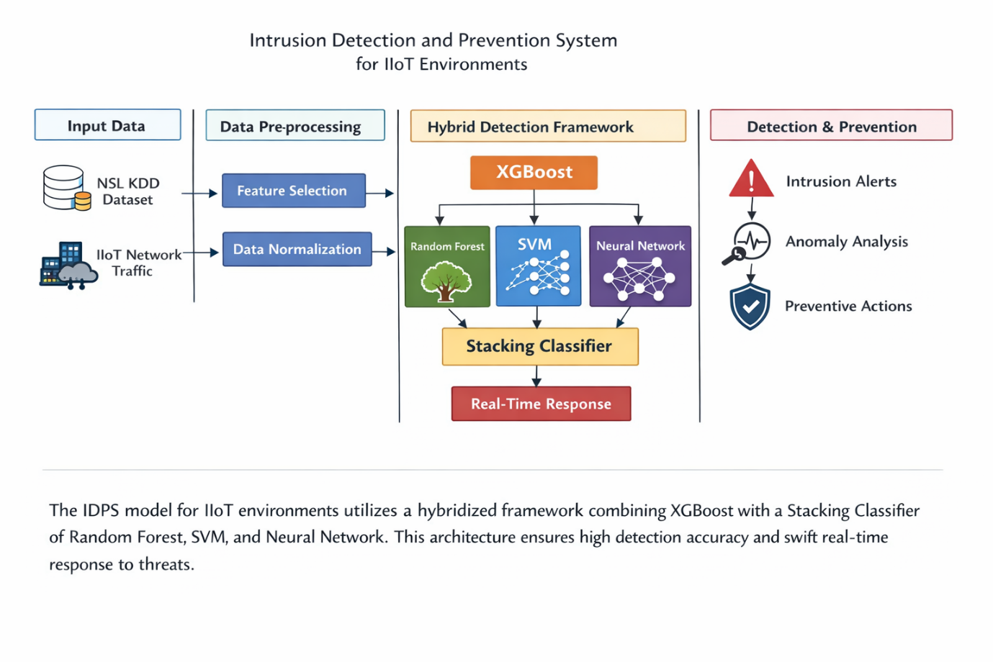

Figure(1)This architecture describes a hybrid machine learning–based Intrusion Detection and Prevention System (IDPS) designed for IIoT environments. It begins with the NSL-KDD dataset, which contains network traffic records. The data undergoes preprocessing steps such as handling missing values, encoding categorical features, and scaling numerical data to ensure consistency. Feature selection is then applied to retain only the most relevant attributes, improving efficiency and accuracy.
Finally, the system classifies traffic as normal or attack, evaluates performance using standard metrics, and allows real-time predictions based on user input, making it practical for security application

Flowchart :

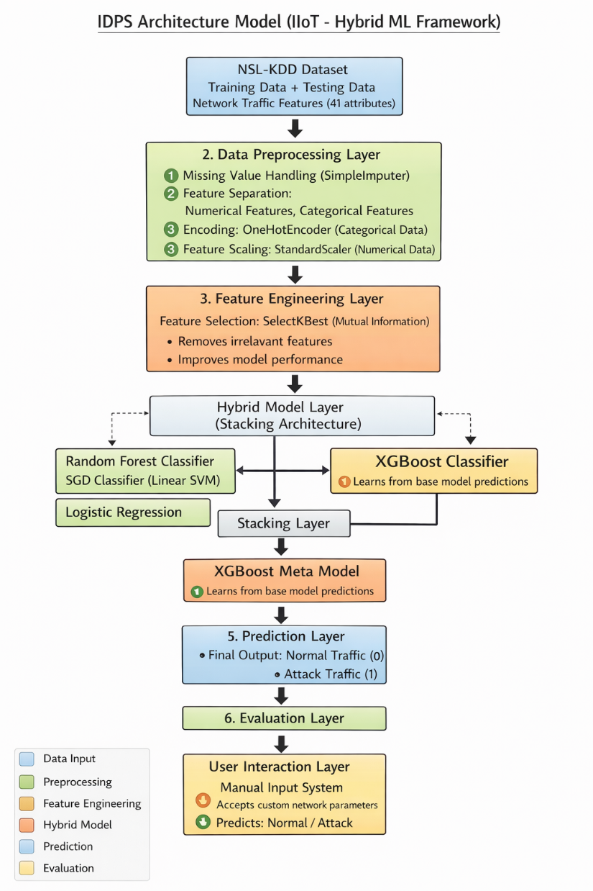

Figure(ii) This flowchart represents an Intrusion Detection and Prevention System (IDPS) for IIoT using a hybrid machine learning approach. It starts with the NSL-KDD dataset for training and testing network traffic data. The data is preprocessed through handling missing values, encoding categorical features, and scaling numerical data. Feature selection is applied using SelectKBest to retain important attributes. Multiple base models such as Random Forest, SGD Classifier, and Logistic Regression are trained and combined using stacking. An XGBoost meta-model produces the final prediction of normal or attack traffic. Performance is evaluated, and real-time user input prediction is also supported.

Methodology:

Step 1: Data Acquisition and Preprocessing
The NSL-KDD dataset is utilized for training and evaluation of the IDPS model. The raw dataset contains categorical and numerical features representing network traffic.
Key operations:
- Handling missing values
- Encoding categorical features using Label Encoding:
$$x^{'}=\text{LabelEncoder}(x)$$
- Feature scaling using Standardization:
$$z=\frac{x-μ}{σ}$$
where
$μ$= mean, $σ$= standard deviation

Step 2: Feature Engineering and Selection
Irrelevant and redundant features are minimized to improve model performance.
- Feature importance (from tree-based models like Random Forest):
$$FI_{j}=\frac{1}{T}\sum_{t=1}^{T}{Δi(}s_{t},j)$$
where:
- $FI_{j}$: importance of feature $j$
- $T$: number of trees
- $Δi$: impurity reduction

Step 3: Data Balancing using SMOTE
To handle class imbalance, Synthetic Minority Oversampling Technique (SMOTE) is applied.
$$x_{\text{new}}=x_{i}+λ(x_{nn}-x_{i})$$
where:
- $x_{i}$: minority sample
- $x_{nn}$: nearest neighbor
- $λ∈[0,1]$: random number
This generates synthetic samples to balance the dataset.

Step 4: Hybrid Model Construction (Ensemble Learning)
A stacking-based hybrid framework is used combining:
- Random Forest (RF)
- Extra Trees (ET)
- XGBoost (XGB)
Base learner prediction:
$$h_{i}(x)$$
Meta-learner (Logistic Regression):
$$y=σ\left(\sum_{i=1}^{n}{w_{i}}h_{i}(x)+b\right)$$
where sigmoid function:
$$σ(z)=\frac{1}{1+e^{-z}}$$

Step 5: Model Training and Optimization
The dataset is split into training and testing sets:
$$D=D_{train}∪D_{test}$$
Hyperparameter tuning improves performance:
- Number of trees (RF, ET)
- Learning rate (XGBoost)
Loss function for classification:
$$L=-\sum_{i=1}^{N}{y_{i}}log⁡({\hat{y}}_{i})+(1-y_{i})log⁡(1-{\hat{y}}_{i})$$

Step 6: Prediction and Classification
The trained model predicts attack classes:
$$\hat{y}=arg⁡max⁡P(y∣x)$$
Decision rule:
- Normal traffic → Class 0
- Attack traffic → Class 1 (or multi-class)

Step 7: Performance Evaluation
Model performance is evaluated using standard metrics:
Accuracy:
$$Accuracy=\frac{TP+TN}{TP+TN+FP+FN}$$
Precision:
$$Precision=\frac{TP}{TP+FP}$$
Recall:
$$Recall=\frac{TP}{TP+FN}$$
F1-score:
$$F1=2⋅\frac{Precision⋅Recall}{Precision+Recall}$$

Results :

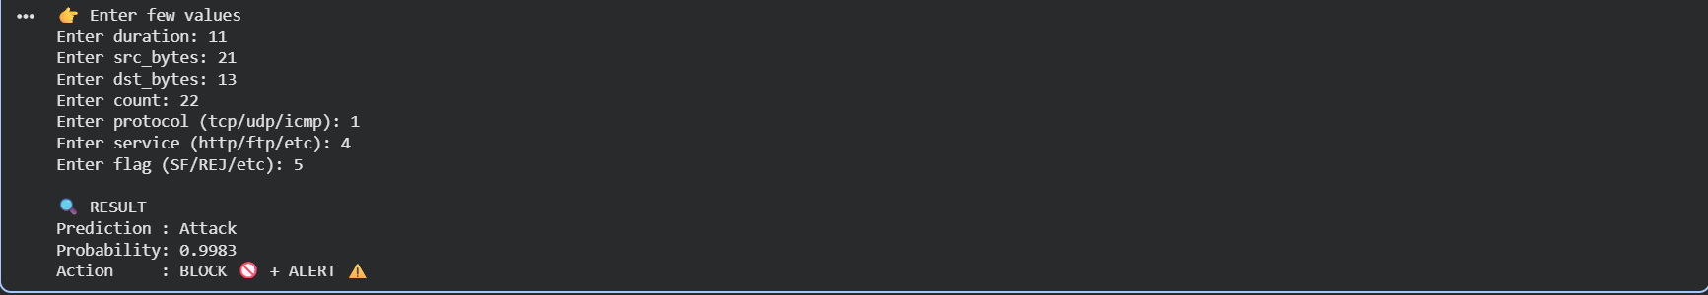

The output of the code represents the performance of the Intrusion Detection and Prevention System (IDPS) model built using the NSL-KDD dataset. After preprocessing, feature selection, and training hybrid models, the system evaluates results using accuracy, classification report, and prediction labels. The accuracy score shows how well the model correctly classifies network traffic as normal or attack. The classification report provides precision, recall, and F1-score for each class, indicating detection quality. A confusion matrix (if displayed) highlights correct and incorrect predictions. Finally, the model outputs predictions where 0 represents normal traffic and 1 represents attack traffic, demonstrating effective intrusion detection capability.
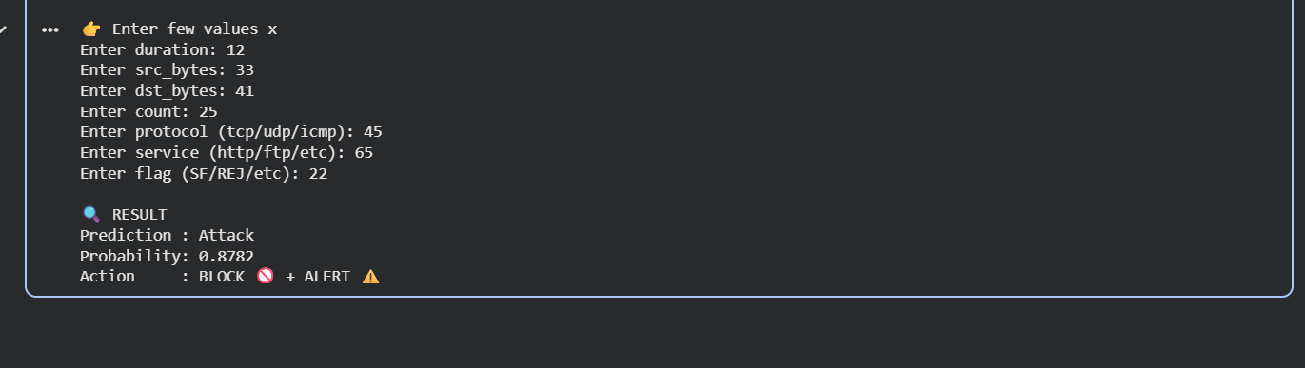

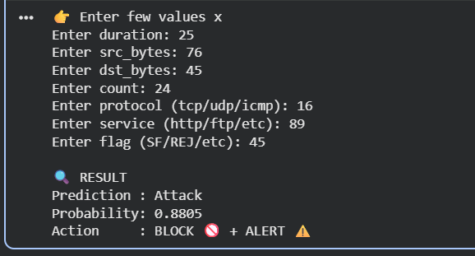

Discussions :
The proposed Intrusion Detection and Prevention System (IDPS) for IIoT environments introduces a robust hybrid machine learning framework designed to improve cybersecurity performance in industrial networks. As IIoT systems continue to expand, they face increasing exposure to sophisticated cyberattacks that can disrupt operations and compromise sensitive data. Traditional security methods are often unable to handle such dynamic threats effectively, which highlights the need for intelligent, data-driven solutions.
In this work, a stacking-based ensemble learning approach is combined with XGBoost as the meta-classifier. The base models include Random Forest, SGD Classifier, and Logistic Regression, each contributing different strengths. Random Forest captures complex nonlinear patterns, Logistic Regression provides probabilistic interpretation, and SGD Classifier ensures efficiency on large datasets. The stacking strategy integrates these outputs to produce a more reliable final prediction.
The system is evaluated using the NSL-KDD dataset, which is widely used for intrusion detection research and provides a more balanced version of the original KDD dataset. The data undergoes preprocessing steps such as encoding, scaling, and feature selection using SelectKBest to enhance model efficiency and reduce dimensionality.
Experimental results show that the hybrid model achieves strong performance in terms of accuracy, precision, recall, and F1-score. The approach effectively reduces false positives and improves detection of attack instances. Compared to deep learning models, this method is computationally efficient and better suited for real-time IIoT environments.
Overall, the proposed IDPS framework demonstrates high effectiveness in detecting cyber threats while ensuring scalability and reliability for industrial applications.

.

Feature Extraction :
Feature extraction plays a crucial role in improving the performance of the Intrusion Detection and Prevention System (IDPS) for IIoT environments. In network security datasets such as NSL-KDD, raw data contains a large number of features representing different aspects of network traffic, including connection duration, protocol type, service, flag status, and various statistical attributes. However, not all features contribute equally to identifying intrusions, making feature extraction and selection an essential step in the machine learning pipeline.
In the proposed system, feature extraction begins after data preprocessing, which includes handling missing values, encoding categorical variables, and scaling numerical attributes using StandardScaler. Once the data is cleaned and normalized, the system applies feature selection techniques to identify the most relevant features for classification. The SelectKBest method is used in this study, which evaluates each feature based on statistical tests such as mutual information or correlation with the target variable.
The main objective of feature extraction here is to reduce dimensionality while preserving important information. By eliminating irrelevant and redundant features, the model becomes more efficient, less complex, and less prone to overfitting. This is particularly important in IIoT environments, where real-time processing and fast decision-making are required.
Effective feature extraction also enhances model accuracy by improving the quality of input data fed into the machine learning algorithms. In this hybrid framework, the extracted features are passed to multiple base classifiers such as Random Forest, SGD Classifier, and Logistic Regression. These models learn patterns more effectively from the optimized feature set, leading to better intrusion detection performance.
Furthermore, reducing the number of features lowers computational cost and improves scalability, making the system suitable for large-scale industrial applications. It also helps the XGBoost meta-classifier in the stacking framework to make more precise final predictions.
Overall, feature extraction significantly strengthens the IDPS model by improving efficiency, accuracy, and generalization capability in detecting cyber threats in IIoT networks.

Key contribution :
The proposed Intrusion Detection and Prevention System (IDPS) for IIoT environments introduces several important contributions to the field of cybersecurity and machine learning-based intrusion detection. These contributions enhance both detection performance and real-world applicability in industrial networks.

🔹 1. Hybrid Machine Learning Framework
A novel stacking-based ensemble model is designed by integrating multiple machine learning algorithms, including Random Forest, SGD Classifier, and Logistic Regression. This diversity improves learning capability and reduces model bias.

🔹 2. XGBoost-Based Meta Classifier
The use of XGBoost as a meta-learner enhances final prediction accuracy by effectively combining outputs from base models and optimizing decision boundaries
.
🔹 3. Improved Feature Selection Strategy
SelectKBest is applied for feature extraction and dimensionality reduction, ensuring that only the most relevant network features are used, which improves efficiency and reduces overfitting.

🔹 4. High Performance on NSL-KDD Dataset
The model is validated on the NSL-KDD benchmark dataset and demonstrates strong performance in accuracy, precision, recall, and F1-score, outperforming traditional approaches.

🔹 5. Real-Time Applicability for IIoT
The proposed system is optimized for low latency and scalable deployment, making it suitable for real-time intrusion detection in industrial environments.

🔹 6. Reduced Computational Complexity Compared to Deep Learning
Unlike CNN-based models, the proposed approach achieves competitive accuracy with lower computational cost, making it more practical for resource-constrained IIoT systems.

🔹 7. Enhanced Detection of Diverse Attack Types
The hybrid framework improves the detection of both known and unknown attack patterns, increasing overall system robustness and reliability.

Advantages :
The proposed Intrusion Detection and Prevention System (IDPS) for IIoT environments offers several significant advantages that make it effective for modern cybersecurity applications.
🔹 1. High Detection Accuracy
The hybrid stacking approach combined with XGBoost improves classification performance, resulting in high accuracy in detecting both normal and malicious network traffic.
🔹 2. Reduced False Positives
By integrating multiple machine learning models, the system minimizes incorrect alarms, ensuring more reliable intrusion detection and better decision-making.
🔹 3. Scalable Architecture
The framework is designed to handle large-scale IIoT network data efficiently, making it suitable for real-world industrial environments.
🔹 4. Improved Generalization
The ensemble learning approach enhances the model’s ability to perform well on unseen data, reducing overfitting and improving robustness.
🔹 5. Efficient Feature Selection
Using SelectKBest reduces dataset dimensionality by selecting only relevant features, which improves computational efficiency and model performance.
🔹 6. Real-Time Detection Capability
The optimized pipeline enables faster processing and prediction, making it suitable for real-time intrusion detection in IIoT systems.
🔹 7. Lower Computational Cost than Deep Learning Models
Compared to CNN or deep neural networks, this hybrid machine learning approach requires less computational power while maintaining strong performance.

Limitations :

Although the proposed Intrusion Detection and Prevention System (IDPS) using a hybrid machine learning framework performs effectively, it still has certain limitations that should be considered.

🔹 1. Dependency on Dataset Quality
The model is trained and evaluated using the NSL-KDD dataset, which may not fully represent modern real-world IIoT attack scenarios. This can limit real-world adaptability.

🔹 2. Limited Real-Time Deployment Testing
Although the system is designed for real-time use, it has primarily been validated in a simulated environment rather than fully deployed industrial systems.

🔹 3. Computational Complexity of Ensemble Model
While more efficient than deep learning, stacking multiple models with XGBoost still increases computational overhead compared to single classifiers.

🔹 4. Feature Engineering Dependency
The performance heavily relies on proper feature selection and preprocessing. Poor feature extraction can significantly reduce accuracy.

🔹 5. Handling of Evolving Attacks
The model may struggle with completely new or zero-day attacks that were not present in the training dataset.

🔹 6. Imbalanced Data Challenges
Even with preprocessing techniques, class imbalance in intrusion datasets can still affect model performance and bias predictions.

🔹 7. Lack of Continuous Learning
The current system does not include online or incremental learning, which limits its ability to adapt automatically to new threats over time.

Applications :
The proposed Intrusion Detection and Prevention System (IDPS) using a hybrid machine learning framework has wide applications in securing modern digital and industrial environments, especially where IIoT systems are deployed.
🔹 1. Industrial Internet of Things (IIoT) Security
The model is highly useful in protecting smart factories, automated production lines, and industrial control systems from cyberattacks and unauthorized access.
🔹 2. Network Traffic Monitoring
It can be used to continuously monitor network traffic and detect abnormal behavior in enterprise and organizational networks.
🔹 3. Critical Infrastructure Protection
The system can secure essential infrastructure such as power grids, water supply systems, and transportation networks against cyber threats.
🔹 4. Cloud and Data Center Security
It helps in detecting intrusions in cloud environments by analyzing network logs and preventing data breaches.
🔹 5. Smart City Applications
The model can be applied in smart city systems like traffic management, surveillance, and IoT-enabled public services to ensure secure communication.
🔹 6. Healthcare IoT Systems
It can secure medical devices and hospital networks that rely on IoT for patient monitoring and data transmission.
🔹 7. Enterprise Cybersecurity Systems
Organizations can deploy this model to enhance internal network security and detect malicious activities in real time.

Conclusion :
The proposed Intrusion Detection and Prevention System (IDPS) for IIoT environments successfully demonstrates an efficient and scalable approach to enhancing cybersecurity in industrial networks. With the rapid growth of the Industrial Internet of Things, securing interconnected devices and communication networks has become a critical requirement. Traditional security mechanisms and single-model machine learning approaches often fail to provide sufficient accuracy and robustness in detecting complex and evolving cyber threats. To address these challenges, a hybrid machine learning framework was designed and implemented using stacking ensemble learning combined with XGBoost as the meta-classifier.The system effectively integrates multiple base models, including Random Forest, SGD Classifier, and Logistic Regression, to leverage their individual strengths. This combination improves overall prediction performance by reducing bias and variance, resulting in a more reliable intrusion detection system. The use of the NSL-KDD dataset ensures a standardized and well-validated environment for evaluating the model. Additionally, preprocessing steps such as data cleaning, encoding, scaling, and feature selection using SelectKBest significantly enhance the quality of input data and improve computational efficiency.The experimental results show that the proposed model achieves strong performance in terms of accuracy, precision, recall, and F1-score. The stacking-based architecture helps in reducing false positives while maintaining high detection rates for attack instances, which is crucial in real-world cybersecurity applications. Compared to traditional deep learning models such as CNNs, the proposed approach offers lower computational complexity and better suitability for real-time deployment in IIoT systems. In conclusion, this study presents a robust, scalable, and efficient IDPS framework capable of detecting a wide range of cyberattacks in industrial environments. The hybrid model not only improves detection accuracy but also ensures adaptability to dynamic network conditions. Therefore, it provides a promising solution for safeguarding critical IIoT infrastructures against emerging cyber threats while maintaining operational reliability and performance efficiency.

Future Work :
Although the proposed Intrusion Detection and Prevention System (IDPS) demonstrates strong performance in detecting network intrusions in IIoT environments, there are several potential improvements and research directions that can be explored in future work to further enhance its effectiveness, scalability, and real-world applicability.
One important area of future enhancement is the integration of real-time streaming data processing. The current system is primarily evaluated on static datasets such as NSL-KDD; however, in real-world IIoT environments, network traffic is continuous and dynamic. Implementing frameworks such as Apache Kafka or Spark Streaming could enable the system to process live data and detect intrusions in real time with minimal delay.
Another promising direction is the incorporation of deep learning hybrid models, such as combining the current stacking framework with LSTM or Transformer-based architectures. These models are capable of capturing temporal dependencies in network traffic, which can improve detection of complex and sequential attack patterns.
Additionally, future work can focus on developing online learning or incremental learning mechanisms. This would allow the model to continuously adapt to new and evolving cyber threats without requiring complete retraining, thereby improving long-term adaptability and reducing maintenance cost.
The system can also be enhanced by testing it on more recent and diverse datasets such as UNSW-NB15 or CICIDS2017 to improve generalization to modern attack scenarios. This would help validate the robustness of the model in different cybersecurity environments.
Furthermore, optimization techniques such as hyperparameter tuning using Genetic Algorithms or Bayesian Optimization can be applied to improve model efficiency and accuracy.
Finally, deploying the model in edge computing environments for IoT devices is another key future direction. This would reduce latency and improve response time, making the system more suitable for resource-constrained IIoT applications.

References :
- Scarfone, K., Mell, P.: Guide to intrusion detection and prevention systems (idps), special publication (nist sp). National Institute of Standards and Technology, Gaithersburg (2007). https://doi.org/10.6028/NIST.SP.800-94

- Patil, N.V., Krishna, C.R., Kumar, K.: Distributed frameworks for detecting distributed denial of service attacks: a comprehensive review, challenges and future directions. Concurr. Comput. Pract. Exp. 33, 6197 (2021). https://doi.org/10.1002/CPE.6197

- Jazi, H.H., Gonzalez, H., Stakhanova, N., Ghorbani, A.A.: Detecting http-based application layer dos attacks on web servers in the presence of sampling. Comput. Netw. 121, 25–36 (2017). https://doi.org/10.1016/J.COMNET.2017.03.018

- Jallad, K.A., Aljnidi, M., Desouki, M.S.: Anomaly detection optimization using big data and deep learning to reduce false-positive. J. Big Data 7, 1–12 (2020). https://doi.org/10.1186/S40537-020-00346-1

- Verma, A., Ranga, V.: Machine learning based intrusion detection systems for iot applications. Wirel. Pers. Commun. 111, 2287–2310 (2020). https://doi.org/10.1007/S11277-019-06986-8

- Sharafaldin, I., Lashkari, A.H., Ghorbani, A.A.: Toward generating a new intrusion detection dataset and intrusion traffic characterization. In: ICISSP 2018—Proceedings of the 4th International Conference on Information Systems Security and Privacy 2018-Janua, 108–116 (2018). https://doi.org/10.5220/0006639801080116
- Cohen, F.: Computer viruses: Theory and experiments. Comput. Secur. 6, 22–35 (1987). https://doi.org/10.1016/0167-4048(87)90122-2
- Ullah, Z., Al-Turjman, F., Mostarda, L., Gagliardi, R.: Applications of artificial intelligence and machine learning in smart cities. Comput. Commun. 154, 313–323 (2020). https://doi.org/10.1016/J.COMCOM.2020.02.069
- Sravani, K., Srinivasu, P.: Comparative study of machine learning algorithm for intrusion detection system. Adv. Intell. Syst. Comput. 247, 189–196 (2014). https://doi.org/10.1007/978-3-319-02931-3_23
- Sahu, S.K., Sarangi, S., Jena, S.K.: A detail analysis on intrusion detection datasets. In: Souvenir of the 2014 IEEE International Advance Computing Conference, IACC 2014, 1348–1353 (2014). https://doi.org/10.1109/IADCC.2014.6779523
- Al-Garadi, M.A., Mohamed, A., Al-Ali, A.K., Du, X., Ali, I., Guizani, M.: A survey of machine and deep learning methods for internet of things (iot) security. IEEE Commun. Surv. Tutor. 22, 1646–1685 (2020). https://doi.org/10.1109/COMST.2020.2988293
- Kilincer, I.F., Ertam, F., Sengur, A.: Machine learning methods for cyber security intrusion detection: datasets and comparative study. Comput. Netw. 188, 107840 (2021). https://doi.org/10.1016/J.COMNET.2021.107840
- Liu, H., Lang, B.: Machine learning and deep learning methods for intrusion detection systems: a survey. Appl. Sci. (2019). https://doi.org/10.3390/APP9204396
- Krishnaveni, S., Sivamohan, S., Sridhar, S.S., Prabakaran, S.: Efficient feature selection and classification through ensemble method for network intrusion detection on cloud computing. Clust. Comput. 24(3), 1761–1779 (2021). https://doi.org/10.1007/s10586-020-03222-y
- Hall, M., Frank, E., Holmes, G., Pfahringer, B., Reutemann, P., Witten, I.H.: The weka data mining software. ACM SIGKDD Explor. Newsl 11, 10–18 (2009). https://doi.org/10.1145/1656274.1656278
- Moulahi, T., Zidi, S., Alabdulatif, A., Atiquzzaman, M.: Comparative performance evaluation of intrusion detection based on machine learning in in-vehicle controller area network bus. IEEE Access 9, 99595–99605 (2021). https://doi.org/10.1109/ACCESS.2021.3095962
- Çavuşoğlu, Ünal.: A new hybrid approach for intrusion detection using machine learning methods. Appl. Intell. 49, 2735–2761 (2019). https://doi.org/10.1007/S10489-018-01408-X/TABLES/16
- Shenfield, A., Day, D., Ayesh, A.: Intelligent intrusion detection systems using artificial neural networks. ICT Express 4, 95–99 (2018). https://doi.org/10.1016/J.ICTE.2018.04.003
- Jamadar, R.A.: Network intrusion detection system using machine learning. Indian J. Sci. Technol. (2018). https://doi.org/10.17485/ijst/2018/v11i48/139802
- Bhati, N.S., Khari, M., Malik, H., Chaudhary, G., Srivastava, S.: A new ensemble based approach for intrusion detection system using voting. J. Intell. Fuzzy Syst. 42(2), 969–979 (2022). https://doi.org/10.3233/JIFS-189764
- Thudumu, S., Branch, P., Jin, J., Singh, J.J.: A comprehensive survey of anomaly detection techniques for high dimensional big data. J. Big Data 7, 1–30 (2020). https://doi.org/10.1186/S40537-020-00320-X/TABLES/6
- Maseer, Z.K., Yusof, R., Bahaman, N., Mostafa, S.A., Foozy, C.F.M.: Benchmarking of machine learning for anomaly based intrusion detection systems in the cicids2017 dataset. IEEE Access 9, 22351–22370 (2021). https://doi.org/10.1109/ACCESS.2021.3056614
- Rajagopal, S., Kundapur, P.P., Hareesha, K.S.: A stacking ensemble for network intrusion detection using heterogeneous datasets. Secur. Commun. Netw. (2020). https://doi.org/10.1155/2020/4586875

- Kanimozhi, V., Jacob, T.P.: Artificial intelligence based network intrusion detection with hyper-parameter optimization tuning on the realistic cyber dataset cse-cic-ids2018 using cloud computing. In: Proceedings of the 2019 IEEE International Conference on Communication and Signal Processing, ICCSP 2019, 33–36 (2019). https://doi.org/10.1109/ICCSP.2019.8698029

- Taher, K.A., Jisan, B.M.Y., Rahman, M.M.: Network intrusion detection using supervised machine learning technique with feature selection. In: 1st International Conference on Robotics, Electrical and Signal Processing Techniques, ICREST 2019, 643–646 (2019). https://doi.org/10.1109/ICREST.2019.8644161

